Workit
Funding Proposal
Digital work marketplace for South Africa's informal economy
Furthersky Solutions · Tshepo M, Founder · 18 July 2026
The ask: R250 000 grant funding over 12 months.
To convert a built, live, compliant platform — and a proven ability to attract workers at near-zero cost — into paid work for young South Africans. Target: 2 000 young people onboarded, 1 200 earning, 4 200 jobs completed, R1.68 million paid directly to workers in Gauteng in Year 1.

1. Executive summary
Workit (workitsa.co.za) is a live South African marketplace that connects households and businesses to nearby, ID-verified workers for everyday jobs — gardening, cleaning, trades, deliveries, errands, care and events. It is built for entry-level Android phones and low data, works in English, Afrikaans and isiZulu, and is free for workers: no registration fee, no commission, no charge of any kind.
The platform is finished and operating. In six weeks of first outreach we registered 90 accounts — 72 workers, 18 employers — at effectively zero acquisition cost, and 58% of those workers are aged 18–34. Worker supply is not our problem.
Our constraint is employer demand, and it is a capital problem. We tested the cheap channel first: 123 businesses contacted by email produced a 2.4% reply rate and no signups. Building real demand in South Africa requires field presence — people on the ground in specific suburbs, signing up property managers, body corporates and small businesses face to face. That is what this funding buys, and it is the only thing standing between a working platform and thousands of young people earning on it.
The return on that spend is unusually direct: at our Year-1 targets, every R1 of grant puts roughly R6.70 into a young person's pocket, at about R208 per young person moved into paid work.
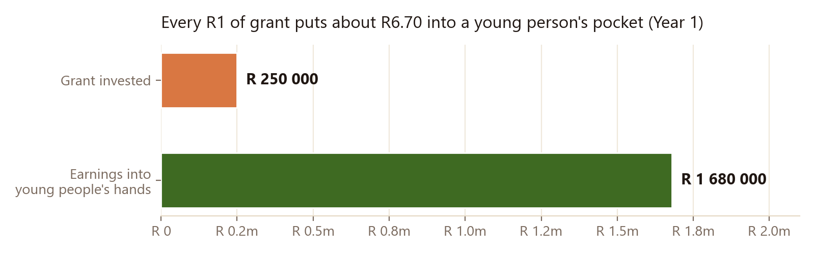

2. The problem we are solving
South Africa's youth unemployment crisis is well documented and needs no restating here. Two features of it shape Workit's design:
- The formal hiring process excludes exactly the people who need work most. A CV, matric certificate, prior experience and contactable references are the standard gate. Millions of capable young South Africans clear none of them and are therefore unemployable on paper — while being entirely able to clean a home, tend a garden, assist a move or run a delivery.
- The work that does exist is invisible. Everyday domestic and small-trade work happens constantly, but it is arranged by word of mouth, paid in cash, and leaves no record. A young person can work for three years and still have no proof of income for a landlord, no work history for an employer, and no credit profile for a lender. The work exists; the evidence of it does not.
Workit addresses both. Entry requires only a verified South African ID and willingness to work. And because every job runs through the platform, each completed job accumulates ratings and a two-sided confirmed payment record into a shareable, verifiable Work Record — turning informal work into documented work history a young person can actually use.
Note for reviewers: the latest Statistics South Africa Quarterly Labour Force Survey figures should be inserted here at submission, cited to the specific quarter.

3. What has already been built — at no cost to any funder
This is not a concept seeking capital to begin. The platform is complete, deployed and in use. It was designed and built by the founder, which is itself the strongest available evidence of capital efficiency:
- A full two-sided marketplace, live. Job posting, worker discovery, offers and counter-offers, hiring, in-app chat, completion, two-way ratings and disputes — plus crew jobs, repeat and recurring bookings, and a worker directory searchable by skill and availability.
- Identity verification and fraud control. SA ID structural validation, ID document and selfie review, duplicate-ID and duplicate-document detection across all accounts, and a ban registry.
- A safety system built for South African conditions. Emergency SOS with GPS that pages the safety team, optional live location sharing, a doorstep start code confirming the right worker at the right address, and one-tap sharing of job details with a family member before the worker travels.
- POPIA compliance infrastructure. Recorded consent, sensitive data isolated behind two-factor-authenticated administrator access, logged access to identity documents, automated data export and erasure, and enforced retention limits. Data is hosted in the africa-south1 region.
- Proof-of-income tooling. Two-sided payment confirmation on every completed job and the shareable Work Record certificate described above.

4. Traction to date — stated plainly
Registered accounts | 90 (72 workers · 18 employers), as at 18 July 2026
Youth share of workers | 58% aged 18–34 (median age 32)
Workers ID-verified | 23, with more in review
Acquisition cost to date | Effectively R0 — no paid advertising has been run
Signup rate during first outreach | 10–14 per day at peak; continuing organically
Jobs during pilot | 4 posted, 1 completed and paid (R598) — the full loop works end to end
Live job posts today | None — this is the problem this proposal addresses
Employer outreach tested | 123 businesses emailed · 2.4% reply · 0 conversions
We are deliberately not dressing this up. Workit has proven it can build a compliant platform and attract workers for free. It has not yet proven it can generate employer demand, because generating demand costs money we have not had. A funder should read the table above as a well-built asset waiting on the one input it lacks.

5. What the funding buys
The money goes where the constraint is. The single largest growth line is field-based employer acquisition, because that is what the evidence says works:
Category | Year 1 | Share
People — founder stipend + operations administrator | R 108 000 | 42%
Marketing, community activation & field ambassadors | R 68 100 | 26%
Infrastructure, cloud, software & communications | R 30 900 | 12%
One-off setup — legal compliance, equipment, accounting, brand | R 30 500 | 12%
Operations — transport, field costs, contingency | R 21 600 | 8%
Total Year-1 spend | R 259 100 | 100%
Funded by the R250 000 grant plus R5 000 founder seed capital and R36 500 of platform revenue beginning in Month 8. The model closes Year 1 with a positive cash balance and never goes negative.
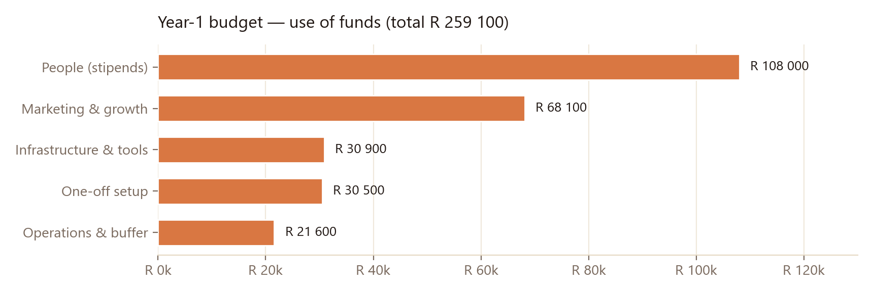

6. Delivery plan and targets
Worker intake is paced to employer demand — deliberately. Recruiting young people into a marketplace with no jobs wastes their data and their hope, so each intake wave is earned by the employer base built ahead of it.
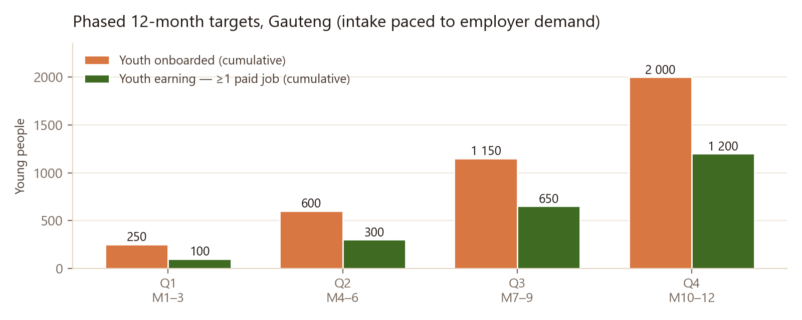
Quarter | Youth onboarded | Verified | Earning ≥1 job | Jobs completed
Q1 · M1–3 | 250 | 175 | 100 | 400
Q2 · M4–6 | 600 | 420 | 300 | 1 100
Q3 · M7–9 | 1 150 | 800 | 650 | 2 400
Q4 · M10–12 | 2 000 | 1 400 | 1 200 | 4 200
Employer targets that gate the above: 150 active employers by end of Q1, 400 by Q2, 900 by Q3, 1 600 by Q4. Geographic sequencing builds density suburb by suburb — Soweto and Johannesburg South, then Tshwane townships, then Ekurhuleni, then the West Rand and Vaal.

7. Milestones and tranches
We propose releasing funds against verifiable milestones, reported from platform data:
Tranche | Amount | Released on | Milestone to unlock next
1 | R 120 000 | Award | Legal sign-off and Information Officer registration complete; 150 employers; 250 youth onboarded; 400 jobs completed
2 | R 70 000 | Month 4 | 600 youth onboarded; 300 earning; 1 100 jobs completed
3 | R 60 000 | Month 7 | 1 150 youth onboarded; 650 earning; 2 400 jobs completed

8. Measurement and reporting
Every figure below is already recorded automatically by the platform; we can report monthly and provide a live administrative view to the funder:
- Young people registered, verified and approved, by source channel
- Young people who completed at least one paid job — our primary success measure, not registrations
- Jobs completed, total value paid to workers, and average earnings per active worker
- Demographics: age band, gender and suburb
- Retention at 30, 60 and 90 days
- Safety incidents and disputes, with resolution

9. Governance, compliance and safeguarding
- Registered entity: Furthersky Solutions, CIPC Reg. 2024/163230/07, South African-owned.
- Minimum age 18, enforced by date-of-birth check at registration.
- POPIA: consent, access control, access logging, export and erasure, and retention enforcement are implemented in the product. Two outstanding items are budgeted and scheduled in Months 1–2: attorney sign-off of the Terms and Privacy Policy, and formal registration of the Information Officer with the Information Regulator.
- Worker classification is disclosed honestly. Workers are independent contractors; income is variable; no UIF or COIDA cover attaches and workers are responsible for their own tax affairs. This is stated in our Terms and repeated during onboarding.
- Administrative access is role-based and protected by mandatory two-factor authentication, with an immutable audit log.

10. Sustainability beyond the grant
Workit is free during launch by choice — liquidity first. From Month 8 a light facilitation fee on confirmed jobs begins, alongside optional paid features already built (featured job listings and verified-business tiers), producing a conservative R36 500 in Year 1 and scaling with job volume thereafter. Because the platform is already built and the founder is technical, the marginal cost of each additional job is close to zero — the business becomes self-sustaining on volume rather than on further capital.

11. Team
- Tshepo M — Founder. Designed and built the entire platform, including the verification, safety and compliance systems. Leads product, engineering, employer acquisition and partnerships.
- Simphiwe Msibi — Operations Administrator (part-time). Account approvals, identity verification review, worker support and dispute handling. Stipend is a funded line in this budget.
- Planned with funding: field ambassadors for on-the-ground employer acquisition and community worker onboarding in target suburbs.

12. Risks and mitigations
Risk | Why it matters | Mitigation
Employer demand does not materialise (primary) | Without jobs, workers churn and impact targets fail | Funds weighted to field-based acquisition; intake paced to demand; monthly reporting makes shortfalls visible early; tranche structure lets the funder stop
Key-person dependency on the founder | One person currently builds and runs the platform | Second administrator already onboarded; documentation maintained; field roles funded to distribute the load
Data costs for young people | Airtime is a genuine barrier | Low-data application; zero-rating being pursued with platform partners
Safety incident involving a worker | Workers enter strangers' premises | Two-sided verification, SOS with GPS, start codes, trusted-contact sharing, live location, disputes and reporting
Underpricing of workers | Desperate workers may accept unfair rates | Workers set and counter-offer their own price; indicative category price guidance published; no rate is ever set on a worker's behalf

13. Why we are building this
Furthersky Solutions did not begin with funding, a team, or a runway. It began with a company registration, an ordinary laptop, and a conviction that the way South Africa matches people to work is broken in a way that can actually be fixed. Every part of Workit — the marketplace, the identity verification, the fraud checks, the safety system, the POPIA controls, the administrative tools — was designed and written by hand, by the founder, without a cent of outside capital. What exists today is therefore not a pitch deck or a prototype: it is a live, compliant platform that real South Africans have signed up to and can use this afternoon. That is the strongest thing we can say about how this company uses money — because so far, it has had almost none.
The road has not been smooth and we will not pretend otherwise. We have rebuilt features that failed in the field, cleaned fraudulent signups out of our own database, sat with the discovery that our first employer outreach strategy did not work at all, and learned — the expensive way — that attracting workers is the easy half of a marketplace. Ninety accounts in six weeks at no acquisition cost told us that young people want this badly. One hundred and twenty-three unanswered emails told us that the businesses who could employ them will never be reached from behind a screen. Those were hard lessons, but they are the right ones to learn early, and they are precisely why this proposal asks for what it asks for: not to build something, but to go out and put the thing we already built in front of the people who can put money in a young person's hand.
We do not offer charity, and we are deliberate about never calling the people who use Workit beneficiaries. They set their own prices, accept or decline their own work, and build a reputation that belongs to them and travels with them. What we supply is the part that has always been missing: a way to be found, a way to be trusted by a stranger, and — for the first time — proof that the work was done and paid for. Every completed job on this platform is somebody's rent, school fees, taxi fare, or the first income they have ever been able to show a landlord or a lender. Our goal for the next twelve months is modest and specific: 1 200 young people in Gauteng earning real money, with the records to prove it. After that, province by province, carefully — because the people who need this most can least afford for us to get it wrong. The longer ambition is simpler still: that a young South African with no matric, no CV and no connections can walk into a bank, a landlord's office or an interview holding a verified record of every job they have ever done, and finally be counted.

Contact: Tshepo M, Founder · Furthersky Solutions · tshepowayne@workitsa.co.za · workitsa.co.za
The platform is live and can be demonstrated at any time, including the administrative reporting view from which every figure in this proposal is drawn. Supporting documents available on request: 12-month cash-flow model, business plan, youth recruitment plan, and security and compliance documentation.

